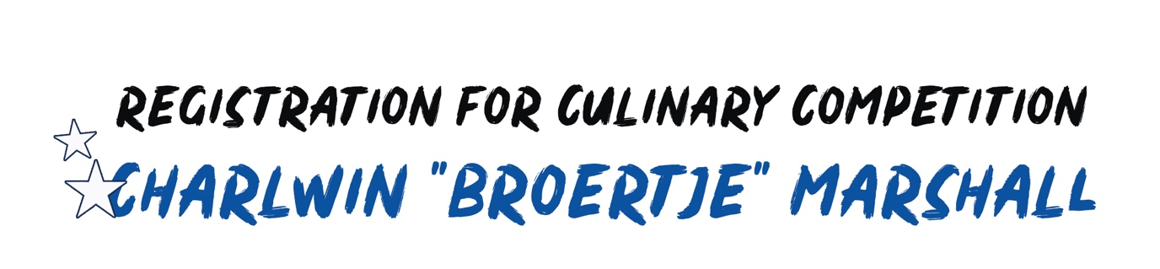

Name:

Address:

Phone: Mobile Phone:

Birthday (dd/mm/yy):

E-mail:

Job Owner:

Job task:

Name of Supervisor:

School name:

*I register myself as a (Mark this with an “X”):

- Junior chef (Age of 16 – 20)

- Senior chef (Age of 21 – 30)

*Every participant must bring their own cooking tools.

Approval: _________________________________________

Name: ___________________________________________

Signature: _________________________________________

This registration form must be sent to:
Activiteiten.owcs@gmail.com with the subject of “Broertje” Marshall or can be delivered at “Sektor Kultura i Deporte, Bon Bini Business Center, Schottegatweg Oost #10”.

